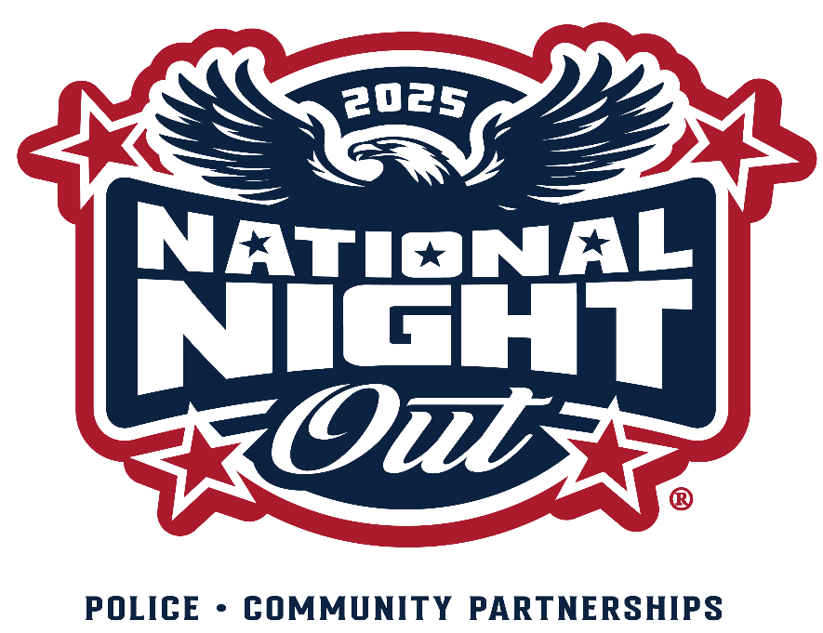
The Golden Valley Police and Fire Departments encourage neighborhoods to collect non-perishable food and/ or personal care items for PRISM Food Shelf. Police and fire personnel will pick up donations while visiting your
neighborhood’s celebration. If we are unable to stop by your gathering, please deliver your donations to the Golden Valley Public Safety building (7700 Golden Valley Rd) by noon on Fri, Aug 8, or call 763-593-8079 to arrange a pick-up.

FOOD/PERSONAL CARE ITEMS NEEDED
- syrup
- cooking oil
- flour/sugar
- canned pasta
- rice
- dried beans
- jam/jelly
- condiments
- spices
- ramen
- canned soup
- canned tuna/chicken/spam
- biscuit/baking mixes
- macaroni & cheese
- boxed potatoes
- cereal
- coffee
- juice
- bottled water
- bar soap
- deodorant
- dish soap
- diapers - all sizes
- disinfecting wipes
- laundry detergent pods
- shampoo/conditioner (full-sized)
- toothbrushes
- toothpaste
- toilet paper
- Kleenex
- feminine hygiene products

